Earthquakes and Continental Drift: Answers
- Interpretations: Earth was atop a giant animal or god that occasionally twitches, causing its burden to shift. A tremendous fish carries a stone on its back, which in turn supports a cow that balances the world first on one horn and then the other… etc.
This is because they believed the Earth to be one solid rock, and were not aware of the idea of continental drift and plate tectonics.

- Scientists believe that earthquakes are brief tremblings of the earth’s crust cause by a sudden movement or shift of rock, which releases energy and creates vibrations within the earth.

- The earth’s crust is broken up into plates that float on molten rock which is constantly moving. Because of these movements (caused by convection currents) the plates are moving (slowly but constantly).
- A) When two continental plates are moving apart, the land gradually rips, creating a rift. This is happening in Africa along the surface of the Great Rift Valley
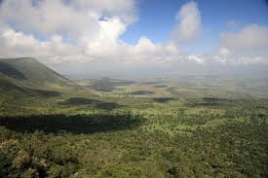

B) When two continental plates collide, they fold the continental crust. Land masses have nowhere to go but up, which results in many of the world’s mountain ranges. An example of this is the Himalayas of Asia, which are still growing as the Indian and Eurasian plates continue to collide.
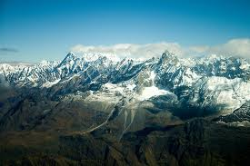

C) When two oceanic plates collide; deep ocean trenches are formed as one plate dives under the other. These trenches are found around the edge of the Pacific Ocean.
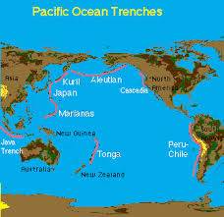

D) When ocean plates spread apart, magma rises up to form new crust, which collects to become undersea mountains. An example is the Mid-Atlantic Ridge (Atlantic Ocean)
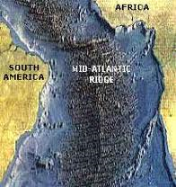
E) When continental and oceanic plates collide, the oceanic plate goes down under the continental plate (subduction). Land rises and ocean floor sinks, leaving mountains and trenches (Andes mountains, and Peru-Chile ocean trench).
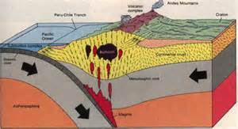

F) When two plates are moving side by side in opposite directions, this creates visible cracks in the surface. At first, surface rocks resist, but then friction and pressure grows, and then we have an earthquake when the plates finally give in. This is happening along the San Andreas Fault in California
